EDITH COWAN UNIVERSITY
School of Engineering
ENS5230.5 — Electrical Machines and Power Systems
Laboratory Report 2
Operating Characteristics of the
Separately-Excited DC Motor
Laboratory Group 2B
STUDENT NAME | STUDENT ID
Anandhu Kaithavalappil Binod | 10730544
Ann Natasha Kaliyath Yesudas | 10716530
Samuel Turnock | 10659280
Saneesh Thekkiniyil | 10263022

Submission Date: 27 September 2026

.

Table of Contents
List of Figures iii
List of Tables iv
1.0 Aim of Experiment 1
2.0 Theoretical Background 1
2.1 Operating principle 1
2.2 Equivalent circuit and governing relationships 1
2.3 Speed droop under mechanical load 2
2.4 Why the armature resistance cannot be measured with an ohmmeter 2
3.0 Equipment and Circuit Configuration 4
3.1 Equipment 4
3.2 Circuit configuration 4
4.0 Method 5
5.0 Results 7
5.1 Armature resistance 7
5.2 Motor speed versus armature voltage (DT211 and G211) 8
5.3 Motor torque versus armature current (DT212 and G212) 9
5.4 Speed as a function of armature current and torque (G212-1 and G212-2) 12
5.5 Predicted speed droop (step 19) 14
6.0 Answers to Review Questions 15
6.1 Questions embedded in the experimental procedure 15
6.1.1 Step 12 — relationship between armature voltage and speed 15
6.1.2 Step 17 — relationship between armature current and torque 15
6.1.3 Step 19 — predicted variation of back-EMF and speed with armature current 15
6.1.4 Step 20 — comparison with measurement and physical explanation 16
6.2 End-of-exercise review questions 16
6.2.1 Question 1 — speed and armature voltage 16
6.2.2 Question 2 — torque and armature current 17
6.2.3 Question 3 — determination of the armature resistance 17
6.2.4 Question 4 — effect of armature current on speed 18
6.2.5 Question 5 — numerical calculation of no-load and full-load speed 18
7.0 Analysis and Discussion 19
7.1 Validity of the linear voltage-to-speed model 19
7.2 Current-to-torque linearity and the onset of armature reaction 19
7.3 Predicted against measured speed droop 20
7.4 Validity of the armature resistance measurement 22
7.5 Energy conversion efficiency 22
7.6 Sources of error and experimental limitations 23
8.0 Conclusion 25
9.0 References 26
10.0 Acknowledgement of Generative Artificial Intelligence 26
Appendix A — Timestamped Laboratory Recordings 27

List of Figures
Figure 1: Simplified equivalent circuit of the armature of a DC motor (redrawn from the Laboratory 2 manual, Figure 7 [2]). 2
Figure 2: Separately-excited DC motor coupled to a brake (redrawn from the Laboratory 2 manual, Figure 13 [2]). Points A and B were left open for the armature resistance test and interconnected for all subsequent measurements. 5
Figure 3: Metering window during the armature resistance test (step 7), recorded at 08:58 on 2 September 2026. 7
Figure 4: Data table DT211 as recorded in LVDAM-EMS at 09:11 on 2 September 2026. 8
Figure 5: Graph G211 — DC motor speed as a function of armature voltage, plotted in LVDAM-EMS. 9
Figure 6: Metering and data table windows at step 14, showing the armature voltage of 255.73 V corresponding to a no-load speed of 1501.52 r/min (09:23 on 2 September 2026). 10
Figure 7: Data table DT212 as recorded in LVDAM-EMS at 09:31 on 2 September 2026 (all forty operating points). 11
Figure 8: Graph G212 — DC motor torque as a function of armature current, plotted in LVDAM-EMS. 12
Figure 9: Graph G212-2 — DC motor speed as a function of developed torque, plotted in LVDAM-EMS at 09:48 on 2 September 2026. 13
Figure 10: Graph G212-1 — DC motor speed as a function of armature current, re-plotted from the recorded DT212 data. 13
Figure 11: Measured torque compared with the linear current-to-torque model fitted below 1.5 A. The measured points fall progressively below the model as the armature current increases. 20
Figure 12: Measured speed droop compared with the model of equation (4), evaluated using the measured armature resistance and using a resistance fitted to the droop. 21
Figure 13: Ratio of mechanical output power to electrical input power as a function of armature current, computed by LVDAM-EMS from the DT212 data. 23
Figure 14: 08:58 — Metering window during the armature resistance test (step 7). The field current of 0.001 A confirms the stator was unexcited; E arm. 14.44 V and I arm. 0.507 A. 27
Figure 15: 09:11 — Data table DT211 complete, showing all eleven no-load operating points from 0.43 V to 271.14 V. 28
Figure 16: 09:12 — Graph G211, motor speed as a function of armature voltage. 28
Figure 17: 09:23 — Step 14: armature voltage set to give a no-load speed of 1500 r/min. E arm. 255.73 V, speed 1501.52 r/min, recorded as the first row of DT212. 28
Figure 18: 09:31 — Data table DT212 complete, showing all forty loaded operating points from 0.28 A to 3.95 A. This is the dataset used throughout Sections 5 and 7. 29
Figure 19: 09:31 — Graph G212, motor torque as a function of armature current, showing the departure from linearity above approximately 1.5 A. 29
Figure 20: 09:48 — Graph G212-2, motor speed as a function of developed torque. 30
Figure 21: 09:48 — Data table displayed alongside graph G212-2. 30

List of Tables
Table 1: Equipment used in the Laboratory 2 exercise. 4
Table 2: Meter readings recorded during the armature resistance measurement. 7
Table 3: Data table DT211 — motor speed as a function of armature voltage at no load (IＦ = 210 mA). 8
Table 4: Data table DT212 — torque, speed and power as a function of armature current at a nominally constant armature voltage of 255.73 V. 10
Table 5: Least-squares current-to-torque constant for different fit ranges, showing the loss of linearity as the upper limit is extended. 12
Table 6: Table 1 of the laboratory manual — predicted armature circuit voltages and motor speed at three armature currents. 14
Table 7: Summary of answers to the end-of-exercise review questions. 16
Table 8: Departure of the measured torque from the linear current-to-torque model (alternate points shown). 20
Table 9: Predicted speed from Table 6 compared with the nearest measured operating point in data table DT212. 20
Table 10: Summary of measured and derived machine parameters. 25

1.0 Aim of Experiment
The aim of this laboratory exercise is to determine by direct measurement the steady-state operating characteristics for a separately-excited direct-current motor and to determine the extent to which the operating characteristics are accurately represented by the simplified equivalent circuit model discussed in the unit material.
The specific objectives were:
- Using the direct current volt-ampere method, measure the armature resistance Rₐ of the Lab-Volt 8211 DC Motor/Generator and explain why an ordinary ohmmeter cannot be used to take this measurement..
- Verify the no-load voltage and speed relationship (Eₐ = Kn₁) of the armature.
- To obtain the armature current to developed torque characteristic for a given armature voltage and to determine the value of K₂, the current to torque constant.
- To determine the limit of linearity of the current to torque characteristic and to calculate the amount of armature reaction that will cause deviation from linearity.
- To estimate the machine's speed droop under load from measured Rₐ and K₁, and to compare with the measured loaded performance.

2.0 Theoretical Background

2.1 Operating principle
The interaction of two magnetic fields, one stationary generated by the stator and the other generated by the current flowing in the rotor (armature) windings, produces continuous rotation of a direct-current motor. The commutator and brush assembly changes the direction of the current in each armature coil when the rotor rotates, which causes the magnetic poles to be formed in the rotor to not rotate with the rotor but to oscillate about a fixed position. The attractive force between the poles of rotor and stator is always in the same direction, and the shaft rotates continuously because the poles of rotor are more or less stationary in space. The more segments on the commutator the smaller the angle through which the poles of the rotor rotate between each commutation and the smoother the developed torque.
If the stator field winding is energized by an independent source, the machine is called "separately excited. Convenience of studying the voltage-speed and current-torque relationships separately is because of this arrangement, which lets the field flux and armature voltage be controlled independently.

2.2 Equivalent circuit and governing relationships
The steady-state behavior of the armature circuit can be shown by the simplified equivalent circuit depicted in Figure 1. The armature voltage Eₐ supplies current Iₐ that flows through armature resistance Rₐ to generate the ohmic drop Eᴿᴬ and against speed-dependent generated voltage Eᴄᴇᴍᶠ.
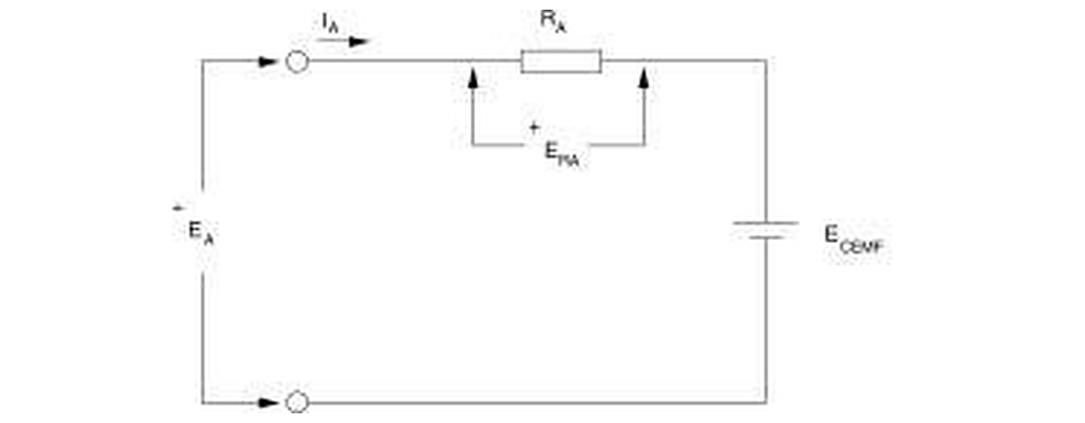
Figure 1: Simplified equivalent circuit of the armature of a DC motor (redrawn from the Laboratory 2 manual, Figure 7 [2]).
Applying Kirchhoff's voltage law around the armature loop gives:
 | Eₐ = Eᴄᴇᴍᶠ + Eᴿᴬ = Eᴄᴇᴍᶠ + Iₐ Rₐ | (1)
The induced voltage is proportional to the speed, and the developed torque is proportional to the armature current, provided the field flux is held constant:
 | n = K₁ · Eᴄᴇᴍᶠ | (2)
 | T = K₂ · Iₐ | (3)
where K₁ is expressed in r/min/V and K₂ in N·m/A. Combining equations (1) and (2) gives the loaded speed of the machine directly in terms of quantities that can be measured at its terminals:
 | n = K₁ (Eₐ − Iₐ Rₐ) | (4)

2.3 Speed droop under mechanical load
Equation (4) shows how the machine behaves with armature voltage kept constant but increasing the load on the machine. A higher load requires higher torque, which in turn requires a higher armature current according to equation (3). Hence, the Ohmic drop IₐRₐ becomes higher; hence, a smaller portion of the applied voltage becomes available as back-EMF, and consequently, the speed drops. Such gradual decrease in speed with the load is called speed droop.:
 | %SR = (n_no-load − n_full-load) / n_full-load × 100 % | (5)
For an ideal machine with constant Rₐ the droop is linear in Iₐ, with a gradient of −K₁Rₐ r/min per ampere.

2.4 Why the armature resistance cannot be measured with an ohmmeter
The armature circuit resistance consists of the contact resistance of the carbon brushes, which is highly non-linear: the voltage drop in the brush contact is more like some fixed value than directly proportional to the current. The needle of the ohmmeter is driven by a small current, which makes the brush drop constant and the actual resistance reading is significantly over-read [2]. The alternative accepted is the direct-current volt ampere method, where the field winding is not energized so that no flux and hence no back EMF is created, the rotor is not permitted to rotate but a voltage is applied to the armature to cause the rated armature current to flow. In such a case, Eᴄᴇᴍᶠ = 0 and equation (1) becomes:
 | Rₐ = Eₐ / Iₐ | (6)
The validity of this method rests on the test being carried out at, or close to, the rated armature current. This point is returned to in Section 7.4, because it proved to be the dominant source of error in the present work.

3.0 Equipment and Circuit Configuration

3.1 Equipment
Model | Description | Qty
8134 | EMS Workstation | 1
8211 | DC Motor / Generator | 1
8311 | Resistive Load | 1
8942 | Timing Belt | 1
8960 | Prime Mover and Dynamometer Module | 1
8821 | Power Supply | 1
8951 | Connection Leads | as required
9063 | Data Acquisition Interface (DAI) | 1
— | LVDAM-EMS software (Metering, Data Table and Graph windows) | 1
Table 1: Equipment used in the Laboratory 2 exercise.

The data acquisition interface was configured with a scale of 800 V / 6 A on a 50 Hz network, as shown in the status bar of every recorded screen capture in Appendix A.

3.2 Circuit configuration
The variable DC output of the 8821 Power Supply was connected to the armature of the DC Motor/Generator current input I1 of the data acquisition interface, with voltage input E1 across the armature terminals. The shunt field winding was provided with a current input I2 in series with the DC motor rheostat, which allowed the field current to be adjusted independently of the armature voltage. The machine was mechanically connected to the 8960 dynamometer using a timing belt and the dynamometer was set up as a brake for the direct measurement of shaft torque and shaft speed.
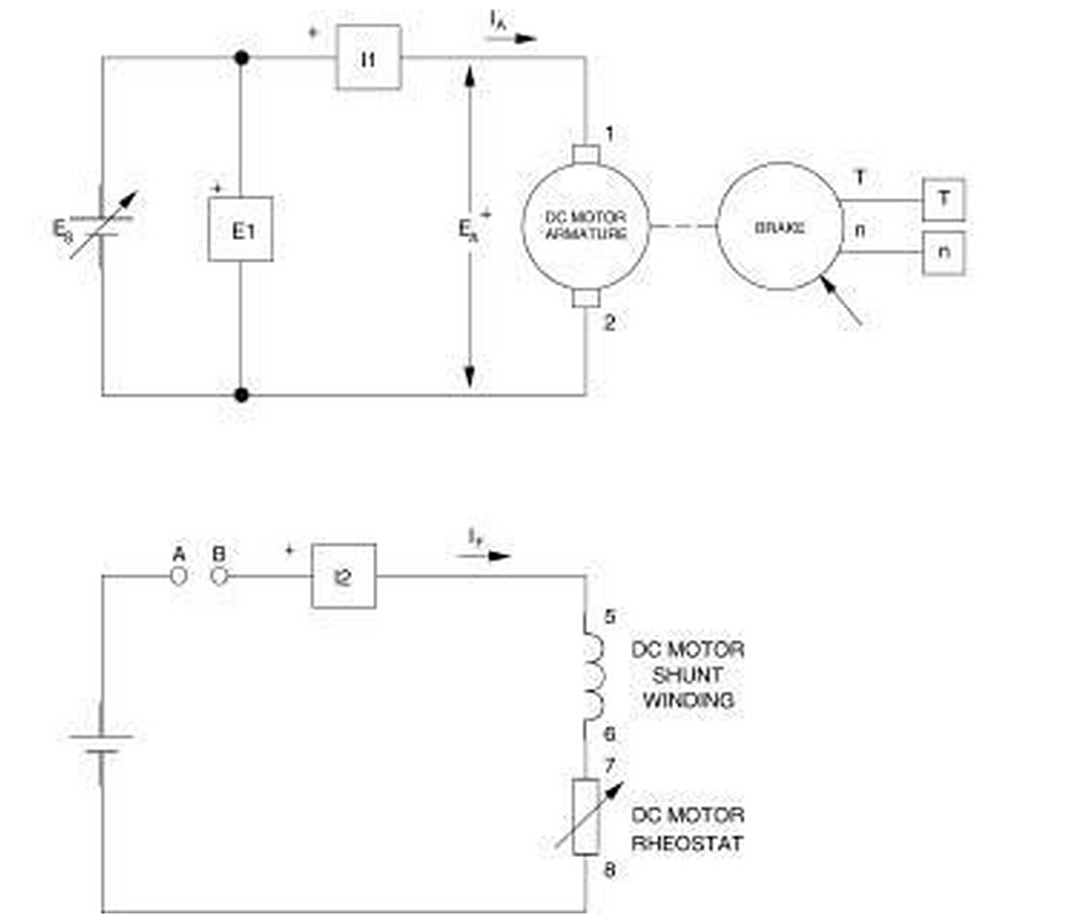
Figure 2: Separately-excited DC motor coupled to a brake (redrawn from the Laboratory 2 manual, Figure 13 [2]). Points A and B were left open for the armature resistance test and interconnected for all subsequent measurements.

4.0 Method
The procedure of the Laboratory 2 manual was followed. The principal steps are summarised below; every quantitative result reported in Section 5 is supported by the corresponding screen capture reproduced in Appendix A.
- Neutral Brush Alignment. Prior to measuring anything, the AC power supply was connected to the armature and adjusted to produce the lowest possible voltage in the shunt field winding as shown on the meter E1. This ensures that the brushes lie on the magnetic neutral axis and reduces sparking and induction of circulating current.
- Armature Resistance (Step 7). In order to obtain the readings for the armature voltage and current at the point when the latter would equal the value used in the test, the armature voltage was increased while there was no current in the field winding.
- Plotting speed against armature voltage (steps 9-13). Points A and B were joined, while the brake torque was minimized and the field rheostat adjusted such that the field current would be 210 mA. The armature voltage was then increased in steps of 5 % from 0 % to 100 % of the supply voltage, waiting for the motor to reach steady-state at each step before taking the readings.
- Torque vs armature current (steps 14 to 18). The data table was cleared, the field current was verified, and the armature voltage was adjusted to obtain a no-load speed of 1500 rpm. The armature voltage was kept constant, and the brake torque was varied in nominal steps of 0.1 N.m, adjusting the armature voltage at each step. The data was recorded in data table DT212 and graphed in G212.
- Speed droop (steps 19–21). The value of the armature resistance and the constant between voltage and speed have been utilized in estimating the speed at three given armature currents. The data from DT212 have been plotted again in terms of speed vs armature current (G212-1) and speed vs torque (G212-2).

5.0 Results

5.1 Armature resistance
With the field winding de-energised the meter readings reproduced in Figure 3 were obtained. The field current of 0.001 A confirms that the stator was unexcited.
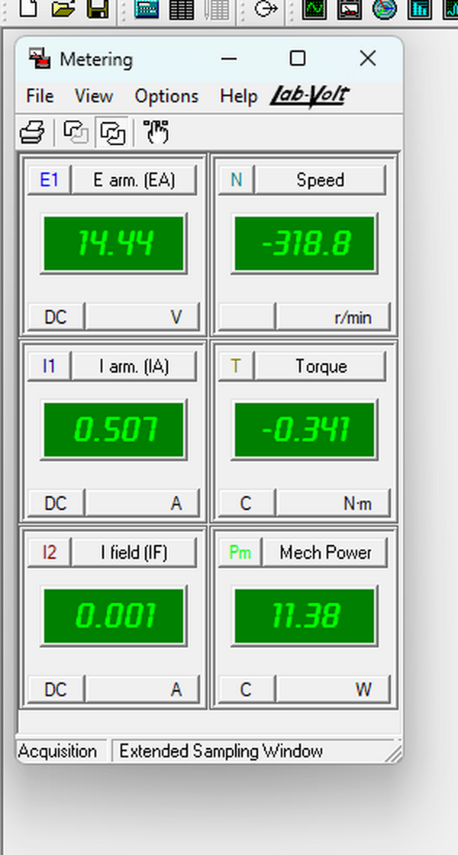
Figure 3: Metering window during the armature resistance test (step 7), recorded at 08:58 on 2 September 2026.
Quantity | Meter | Reading
Armature voltage Eₐ | E arm. (EA) | 14.44 V
Armature current Iₐ | I arm. (IA) | 0.507 A
Field current IＦ | I field (IF) | 0.001 A
Shaft speed n | Speed | −318.8 r/min
Shaft torque T | Torque | −0.341 N·m
Table 2: Meter readings recorded during the armature resistance measurement.

Applying equation (6):
 | Rₐ = Eₐ / Iₐ = 14.44 / 0.507 = 28.48 Ω | (7)
The value of armature resistance is thus presented to be 28.48 Ω. There are two aspects of this reading that need to be explained and discussed in section 7.4, namely the test current of 0.507A and the speed meter reading of -318.8r/min.

5.2 Motor speed versus armature voltage (DT211 and G211)
The no-load data recorded in data table DT211 are reproduced in Table 3. The field current held steady at 0.20–0.21 A throughout, and the armature current remained below 0.3 A, confirming that the machine was effectively unloaded.
# | Eₐ (V) | Iₐ (A) | IＦ (A) | P_IN (W) | T (N·m) | n (r/min)
0 | 0.43 | 0.01 | 0.21 | 0.01 | 0.00 | 0.08
1 | 26.03 | 0.18 | 0.20 | 4.64 | 0.21 | 126.00
2 | 53.17 | 0.20 | 0.20 | 10.58 | 0.23 | 285.97
3 | 82.58 | 0.22 | 0.20 | 18.55 | 0.25 | 459.05
4 | 108.93 | 0.24 | 0.20 | 26.46 | 0.26 | 614.33
5 | 136.59 | 0.26 | 0.20 | 35.54 | 0.28 | 779.98
6 | 160.82 | 0.27 | 0.20 | 43.20 | 0.29 | 922.85
7 | 187.72 | 0.27 | 0.20 | 52.12 | 0.30 | 1083.56
8 | 213.66 | 0.28 | 0.20 | 61.09 | 0.31 | 1240.19
9 | 239.94 | 0.29 | 0.20 | 70.42 | 0.32 | 1394.89
10 | 271.14 | 0.29 | 0.20 | 80.62 | 0.33 | 1581.36
Table 3: Data table DT211 — motor speed as a function of armature voltage at no load (IＦ = 210 mA).

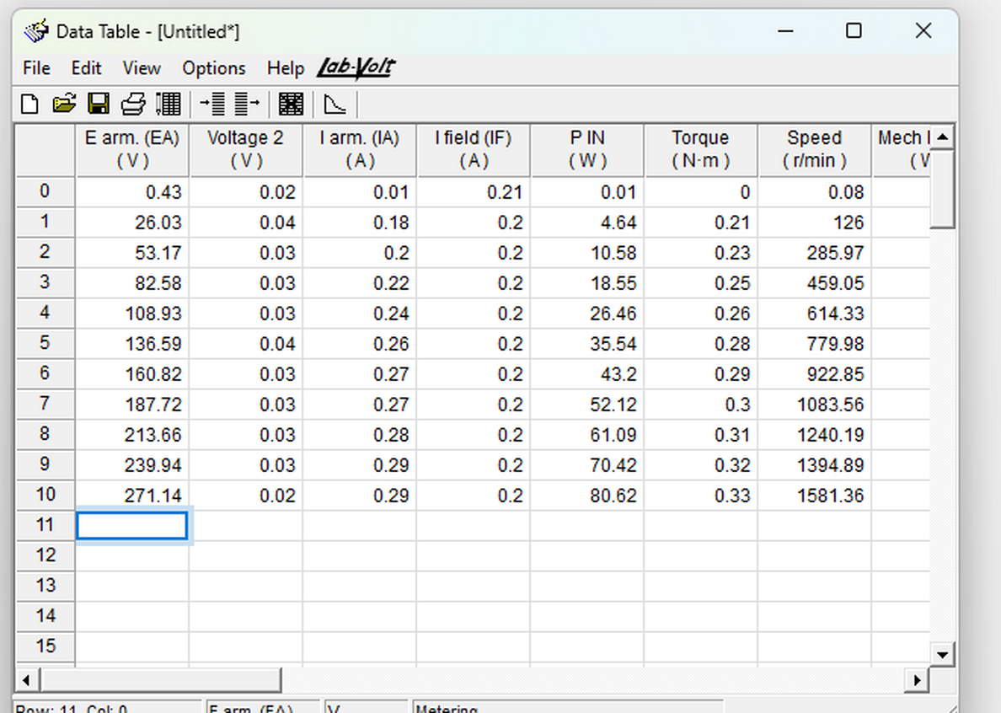
Figure 4: Data table DT211 as recorded in LVDAM-EMS at 09:11 on 2 September 2026.
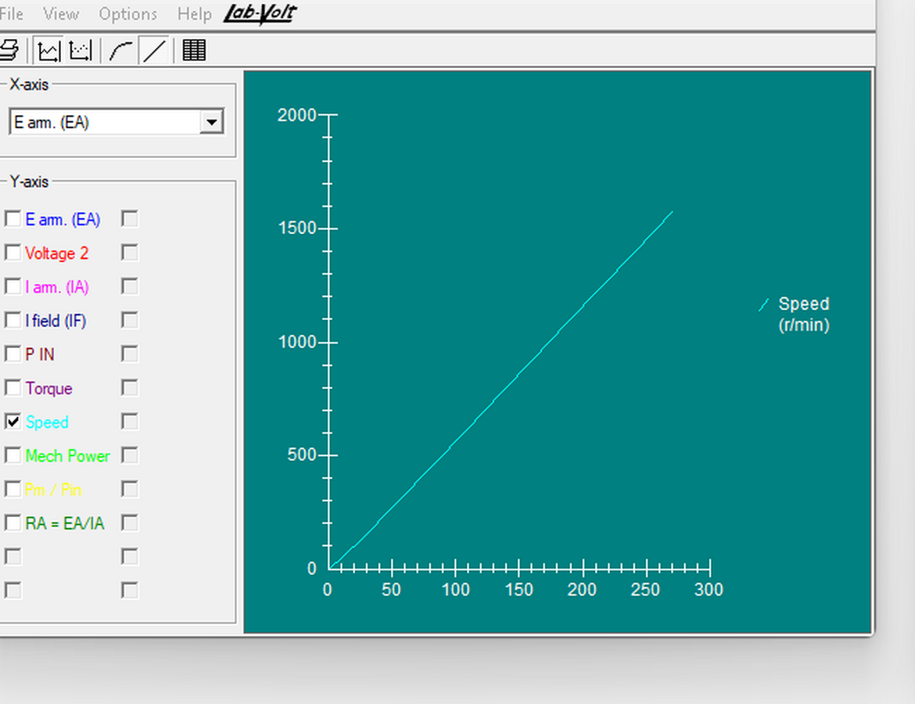
Figure 5: Graph G211 — DC motor speed as a function of armature voltage, plotted in LVDAM-EMS.
The characteristic is a straight line passing close to the origin. Using the two end points of the data table as directed in step 13:
 | K₁ = Δn / ΔEₐ = (1581.36 − 0.08) / (271.14 − 0.43) = 5.841 r/min/V | (8)
The least squares regression line for all eleven data points yields the slope of 5.893 r/min/V and coefficient of determination of R² = 0.9998, which proves that the relation is linear up to the accuracy of the measurement equipment. The value of K₁ = 5.841 r/min/V determined via the two-point method will be used in all further calculations according to the laboratory protocol.

5.3 Motor torque versus armature current (DT212 and G212)
The armature voltage required to produce a no-load speed of 1500 r/min was recorded in step 14 as:
 | Eₐ = 255.73 V at n = 1500 r/min | (9)
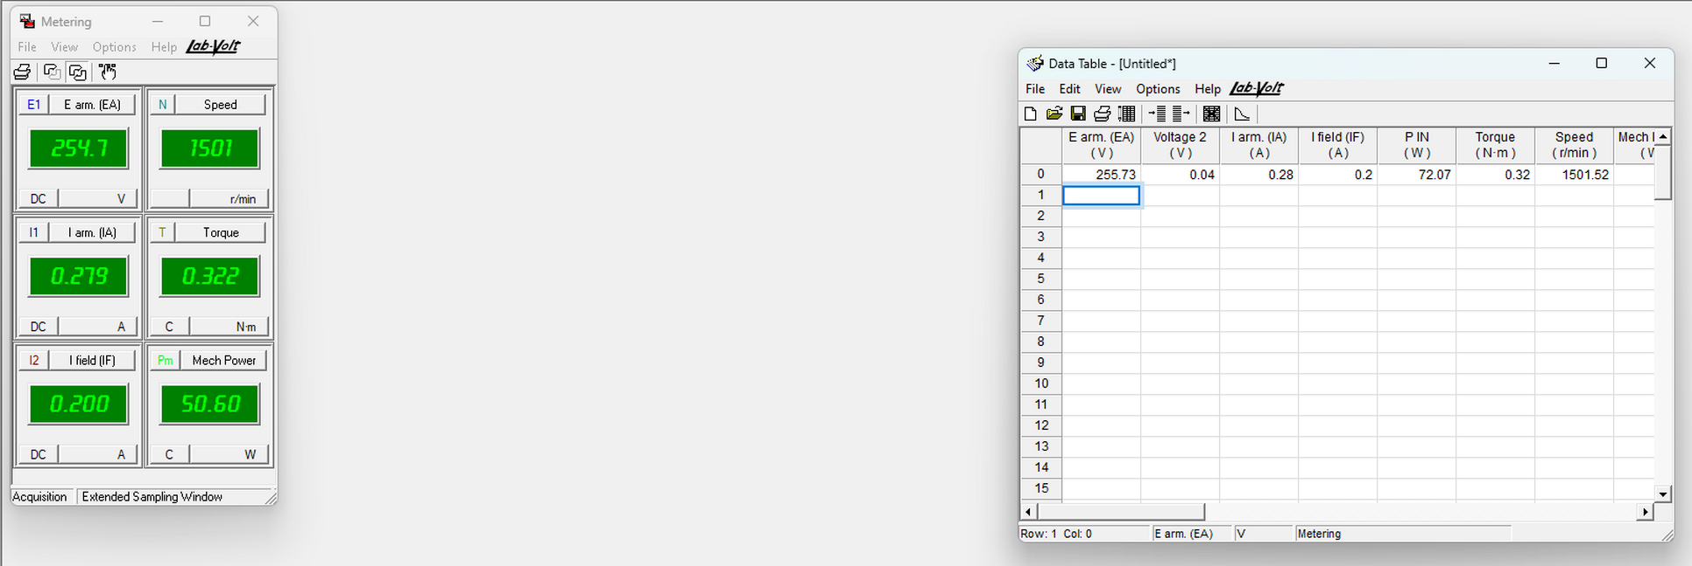
Figure 6: Metering and data table windows at step 14, showing the armature voltage of 255.73 V corresponding to a no-load speed of 1501.52 r/min (09:23 on 2 September 2026).
The brake torque was then increased in increments while the armature voltage was held at this value. Forty operating points were recorded, reproduced in Table 4.
# | Eₐ (V) | Iₐ (A) | IＦ (A) | P_IN (W) | T (N·m) | n (r/min) | Pₘ (W) | η (%)
0 | 255.73 | 0.28 | 0.20 | 72.07 | 0.32 | 1501.52 | 50.63 | 70.24
1 | 252.74 | 0.28 | 0.20 | 72.46 | 0.35 | 1499.06 | 54.47 | 75.18
2 | 252.88 | 0.32 | 0.20 | 82.10 | 0.40 | 1492.44 | 62.75 | 76.43
3 | 252.91 | 0.36 | 0.20 | 92.74 | 0.46 | 1477.29 | 70.70 | 76.24
4 | 252.82 | 0.40 | 0.20 | 103.38 | 0.52 | 1462.26 | 78.88 | 76.30
5 | 252.64 | 0.43 | 0.20 | 110.49 | 0.56 | 1462.12 | 84.98 | 76.91
6 | 252.50 | 0.47 | 0.20 | 119.75 | 0.61 | 1461.53 | 92.62 | 77.35
7 | 252.44 | 0.50 | 0.20 | 128.67 | 0.66 | 1453.14 | 100.11 | 77.80
8 | 252.28 | 0.56 | 0.20 | 142.74 | 0.73 | 1443.73 | 109.92 | 77.01
9 | 252.37 | 0.60 | 0.20 | 152.52 | 0.78 | 1453.51 | 118.97 | 78.00
10 | 251.95 | 0.65 | 0.20 | 164.77 | 0.84 | 1438.24 | 127.22 | 77.21
11 | 251.71 | 0.69 | 0.20 | 174.33 | 0.89 | 1441.41 | 134.81 | 77.33
12 | 251.65 | 0.73 | 0.20 | 185.93 | 0.95 | 1439.30 | 142.64 | 76.72
13 | 251.17 | 0.77 | 0.20 | 195.62 | 0.99 | 1432.59 | 149.13 | 76.23
14 | 251.27 | 0.84 | 0.20 | 211.36 | 1.07 | 1427.05 | 160.62 | 75.99
15 | 251.19 | 0.88 | 0.20 | 223.62 | 1.14 | 1433.82 | 170.65 | 76.31
16 | 250.96 | 0.93 | 0.20 | 234.92 | 1.19 | 1422.61 | 176.57 | 75.16
17 | 250.80 | 0.97 | 0.20 | 244.95 | 1.23 | 1425.06 | 183.92 | 75.08
18 | 250.97 | 1.02 | 0.20 | 256.36 | 1.28 | 1425.09 | 191.56 | 74.72
19 | 250.70 | 1.16 | 0.20 | 293.23 | 1.44 | 1417.57 | 214.18 | 73.04
20 | 250.31 | 1.27 | 0.20 | 319.21 | 1.54 | 1418.89 | 228.91 | 71.71
21 | 250.32 | 1.33 | 0.20 | 335.22 | 1.60 | 1415.50 | 237.08 | 70.72
22 | 250.11 | 1.38 | 0.20 | 346.00 | 1.64 | 1419.54 | 243.54 | 70.39
23 | 249.97 | 1.46 | 0.20 | 365.99 | 1.71 | 1409.04 | 251.80 | 68.80
24 | 249.83 | 1.50 | 0.20 | 376.53 | 1.75 | 1412.45 | 258.13 | 68.56
25 | 249.51 | 1.59 | 0.20 | 399.02 | 1.81 | 1405.96 | 266.49 | 66.79
26 | 249.35 | 1.63 | 0.20 | 409.19 | 1.85 | 1411.35 | 273.04 | 66.73
27 | 249.11 | 1.68 | 0.20 | 419.81 | 1.88 | 1410.48 | 278.37 | 66.31
28 | 248.88 | 1.76 | 0.20 | 438.85 | 1.93 | 1393.70 | 281.89 | 64.23
29 | 248.85 | 1.82 | 0.20 | 454.61 | 1.98 | 1409.10 | 292.67 | 64.38
30 | 248.41 | 1.90 | 0.20 | 474.41 | 2.04 | 1399.07 | 298.61 | 62.94
31 | 248.35 | 1.98 | 0.20 | 493.69 | 2.08 | 1396.34 | 303.93 | 61.56
32 | 248.15 | 2.07 | 0.20 | 516.25 | 2.14 | 1396.23 | 313.18 | 60.66
33 | 247.78 | 2.26 | 0.19 | 561.79 | 2.24 | 1358.41 | 318.99 | 56.78
34 | 247.34 | 2.42 | 0.20 | 600.14 | 2.34 | 1347.34 | 330.37 | 55.05
35 | 246.97 | 2.58 | 0.19 | 638.68 | 2.43 | 1317.12 | 334.89 | 52.43
36 | 246.54 | 2.77 | 0.19 | 684.38 | 2.52 | 1284.36 | 338.83 | 49.51
37 | 245.75 | 3.05 | 0.19 | 752.96 | 2.57 | 1133.84 | 305.09 | 40.52
38 | 244.39 | 3.59 | 0.19 | 880.53 | 2.87 | 1147.08 | 344.38 | 39.11
39 | 243.25 | 3.95 | 0.19 | 965.66 | 2.96 | 1079.88 | 334.94 | 34.68
Table 4: Data table DT212 — torque, speed and power as a function of armature current at a nominally constant armature voltage of 255.73 V.

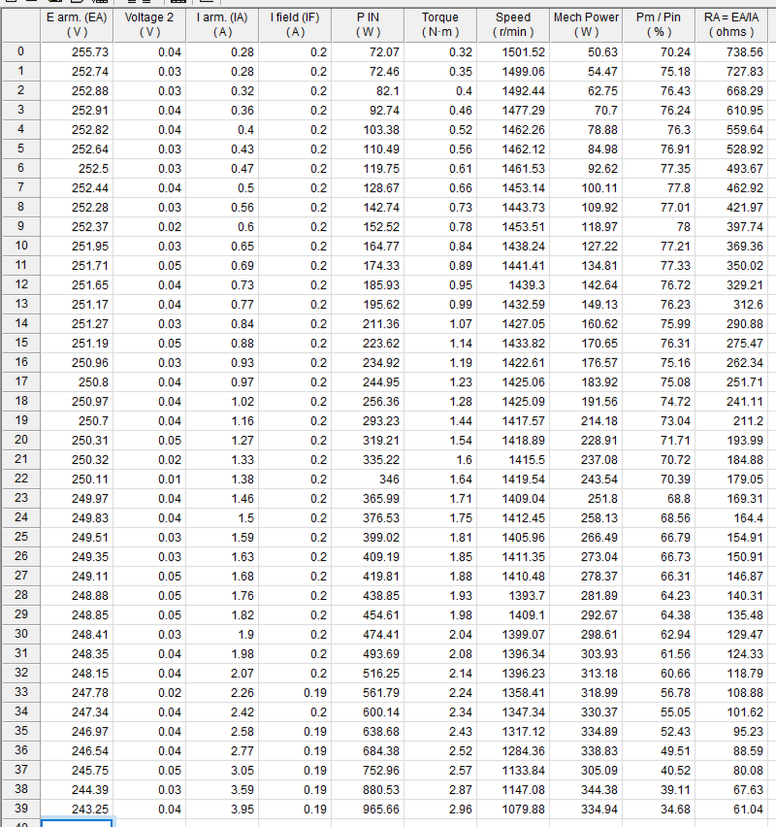
Figure 7: Data table DT212 as recorded in LVDAM-EMS at 09:31 on 2 September 2026 (all forty operating points).
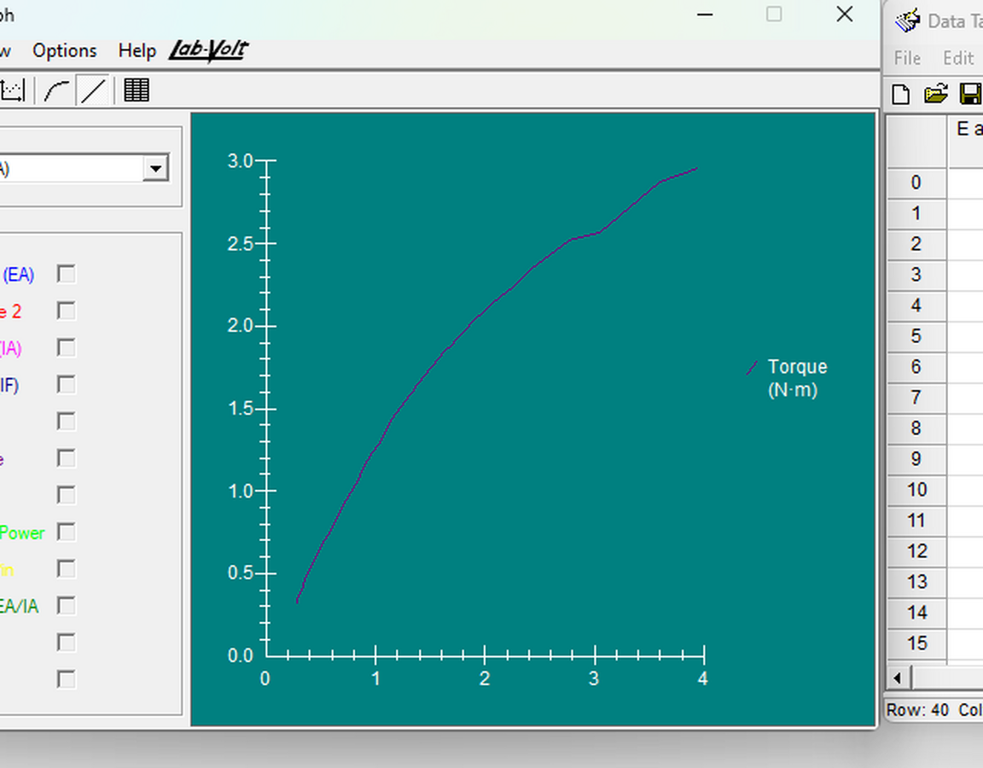
Figure 8: Graph G212 — DC motor torque as a function of armature current, plotted in LVDAM-EMS.
The characteristic is linear at low current but bends progressively away from the straight line as the current rises. Taking the two end points of the linear portion, which extends to approximately 1.5 A:
 | K₂ = ΔT / ΔIₐ = (1.75 − 0.32) / (1.50 − 0.28) = 1.172 N·m/A | (10)
The sensitivity of this constant to the range chosen for the fit is summarised in Table 5.
Fit range | Points | K₂ (N·m/A) | R²
Iₐ ≤ 1.00 A | 18 | 1.295 | 0.9980
Iₐ ≤ 1.50 A | 25 | 1.164 | 0.9943
Iₐ ≤ 2.00 A | 32 | 1.049 | 0.9881
All 40 points | 40 | 0.780 | 0.9438
Table 5: Least-squares current-to-torque constant for different fit ranges, showing the loss of linearity as the upper limit is extended.

5.4 Speed as a function of armature current and torque (G212-1 and G212-2)
Graph G212-2, speed against torque, was plotted in LVDAM-EMS and is reproduced in Figure 9. Graph G212-1, speed against armature current, was not captured during the laboratory session; it has therefore been re-plotted in Figure 10 directly from the forty recorded points of data table DT212, which are listed in full in Table 4 and evidenced by the screen capture in Figure 7.
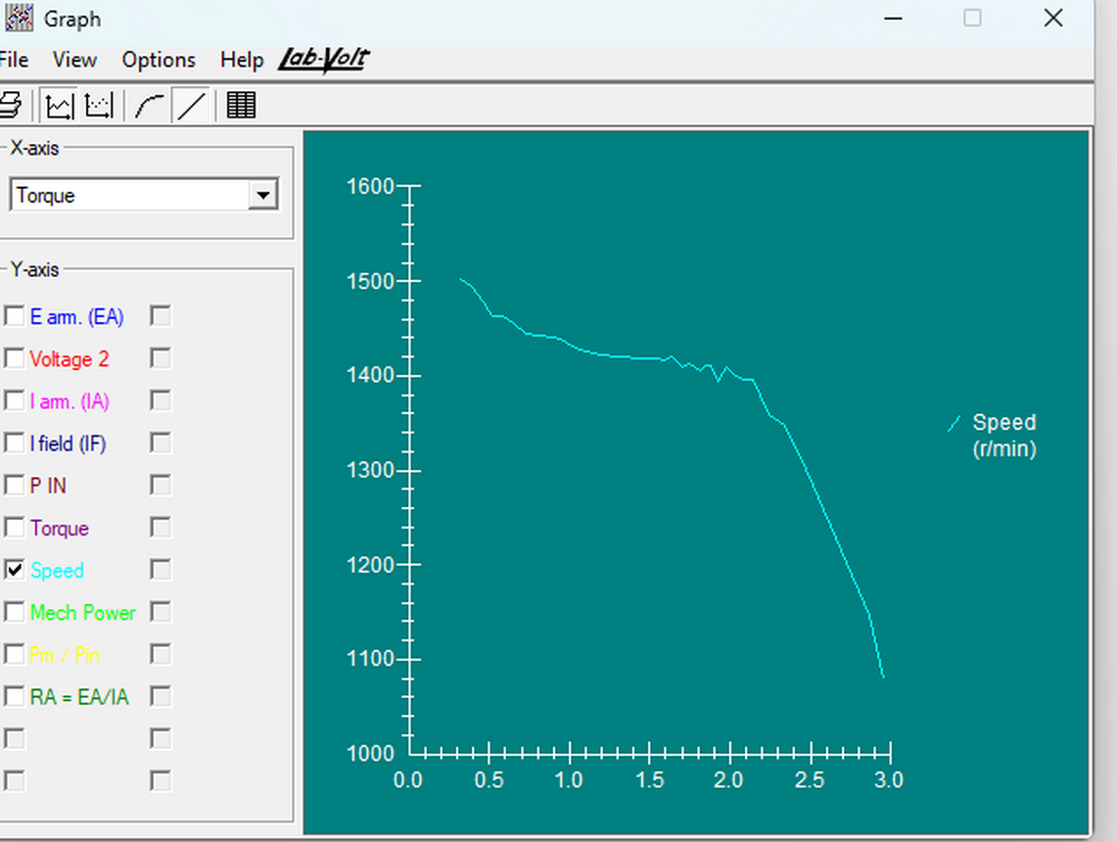
Figure 9: Graph G212-2 — DC motor speed as a function of developed torque, plotted in LVDAM-EMS at 09:48 on 2 September 2026.
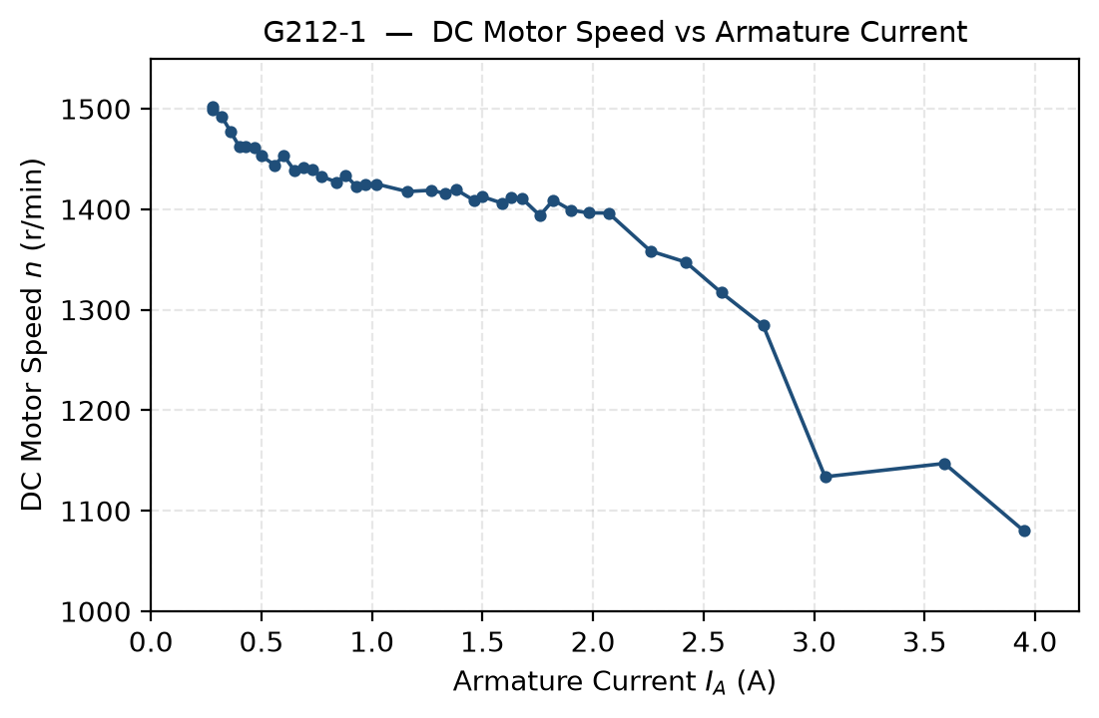
Figure 10: Graph G212-1 — DC motor speed as a function of armature current, re-plotted from the recorded DT212 data.
Both characteristics fall monotonically: the speed decreases steadily as either the armature current or the developed torque increases, in the manner anticipated by equation (4).

5.5 Predicted speed droop (step 19)
With the value of the resistance of the armature Rₐ = 28.48Ω, the voltage to speed constant K₁ = 5.841 r/min/volt, and the armature voltage Eₐ = 255.73V obtained in step 14, the speed was calculated for the three different armature currents using the formulae Eᴿᴬ = IₐRₐ, Eᴄᴇᴍᶠ = Eₐ − Eᴿᴬ and n = K₁Eᴄᴇᴍᶠ.
Local AC network | 240 Vᴀᴄ | 240 Vᴀᴄ | 240 Vᴀᴄ
Armature current Iₐ (A) | 0.5 | 1.0 | 1.5
Eᴿᴬ (V) | 14.24 | 28.48 | 42.72
Eᴄᴇᴍᶠ (V) | 241.49 | 227.25 | 213.01
n (r/min) | 1410.6 | 1327.4 | 1244.2
Table 6: Table 1 of the laboratory manual — predicted armature circuit voltages and motor speed at three armature currents.

6.0 Answers to Review Questions
Two different types of questions appear in the Laboratory 2 manual: questions that appear within the lab itself, which are answered based on the data collected during the lab procedure, and five multiple choice questions found at the end of the lab procedure. The answers to both types of questions are provided below.

6.1 Questions embedded in the experimental procedure

6.1.1 Step 12 — relationship between armature voltage and speed
From graph G211, one can see that the speed of the motor varies directly with respect to the armature voltage. The relation in the form of a line passes through or is close to the origin with a fit that gives an R² value of 0.9998 with an intercept of only -21.8 r/min; this value is less than 1.4% of the highest speed noted.
From the graph above, it is clear that for a no-load condition with a constant field current, the separately excited DC motor acts as a voltage-to-speed converter, meaning that when the armature voltage increases, the speed increases accordingly at a rate of K₁ = 5.841 r/min/V. This is because of equation (1) and (2) whereby under the no-load condition, the armature current is very small such that the ohmic drop (IₐRₐ) becomes insignificant and Eᴄᴇᴍᶠ ≅ Eₐ.

6.1.2 Step 17 — relationship between armature current and torque
If the current in the armature does not go beyond the rated one, then the torque is directly proportional to the armature current. In the range of 0 to 1.5 A, the slope obtained using the method of least squares is 1.164 N·m/A with R² = 0.9943; while the slope needed according to step 18 is K₂ = 1.172 N·m/A. Thus, it is concluded that for this current range, the motor acts as a linear current-to-torque converter, such that the greater the current in the armature, the greater the torque.
After the value of 1.5 A, the observed torque is progressively less than the one expected from the linear model, as seen in Figure 8 and Figure 11. At the maximum current value of 3.95 A, the torque measured is 2.96 N·m, which is 36 % below the linear extrapolation. This is the expected behavior due to the armature reaction.

6.1.3 Step 19 — predicted variation of back-EMF and speed with armature current
From the calculations made in Table 6, the back EMF and speed are supposed to fall linearly with increase in armature current. Armature voltage remains constant and any extra ampere of armature current results in an increase of IₐRₐ in ohmic losses while it reduces the back-EMF by an equal amount since Rₐ = 28.48 Ω; the back-EMF is expected to fall by 28.48 V/ampere. Since the speed is directly proportional to back EMF through K₁, the speed is expected to fall by K₁Rₐ = 166 r/min per ampere. Over the given range of values, the back-EMF is expected to fall from 241.49 V to 213.01 V while the speed is expected to fall from 1410.6 r/min to 1244.2 r/min.

6.1.4 Step 20 — comparison with measurement and physical explanation
Graph G212-1 (Figure 10) confirms the direction of the prediction. The measured speed decreases monotonically as the armature current increases, from 1501.52 r/min at 0.28 A to 1079.88 r/min at 3.95 A, so the qualitative prediction made in step 19 is supported by the measurements.
The droop is, however, much less than expected. With an armature current of 1.5 A, the model gives 1244.2 r/min while the actual speed is 1412.45 r/min. In terms of slopes, the model under-estimates the actual speed loss by a factor of 2.6. This difference will be discussed in Section 7.3 and is due to the value of the armature resistance rather than being a deficiency in the model.
The reason for the speed droop is the ohmic voltage drop across the armature resistance. An increase in the brake torque makes the motor produce higher torque. By (3), the motor draws a higher armature current. For a constant supply voltage, there is now a higher voltage drop of IₐRₐ across the armature resistance. This means that the back-EMF voltage is smaller and therefore the speed of rotation of the armature is reduced. An equilibrium is attained when the speed is low enough for the back-EMF to draw the correct armature current to balance the torque.

6.2 End-of-exercise review questions
Below are the five multiple-choice questions included in the exercise, which have been reproduced along with the chosen answer and explanation. Wherever the question has any relationship with any quantity determined in this exercise, the respective measurement has been mentioned. The table 7 below summarizes the answers chosen.
Q | Answer | Basis
1 | (a) A linear relationship | G211 is a straight line; R² = 0.9998
2 | (a) A linear relationship | G212 is linear below nominal current; R² = 0.9943
3 | (c) The armature resistance | The volt-ampere method of step 7
4 | (b) It decreases | Measured droop 1501.52 → 1079.88 r/min
5 | (b) 995 r/min and 875 r/min | n = K₁(Eₐ − IₐRₐ) evaluated at 2 A and 50 A
Table 7: Summary of answers to the end-of-exercise review questions.

6.2.1 Question 1 — speed and armature voltage
What kind of relationship exists between the speed and armature voltage of a separately-excited dc motor? (a) A linear relationship. (b) A parabolic relationship. (c) An exponential relationship. (d) The speed of the motor is independent of the applied voltage.
Answer: (a) A linear relationship.
With constant field current, the flux is constant and therefore the induced voltage is proportional to the speed, as shown by the relation n = K₁Eᴄᴇᴍᶠ. In no-load condition, the armature current is small and the resistance drop IₐRₐ is small and can be neglected, therefore Eᴄᴇᴍᶠ ≈ Eₐ and hence the speed is proportional to the armature voltage. This was demonstrated directly by the experiments of Section 5.2 where graph G211 (Figure 5) is a straight line and a least squares fit through all the eleven points gives R² = 0.9998 without any curving that would show parabolic/exponential function. The option (d) contradicts with the results as the speed increased from 0.08 r/min to 1581.36 r/min when the armature voltage was increased.

6.2.2 Question 2 — torque and armature current
What kind of relationship exists between the torque and armature current of a separately-excited dc motor as long as the armature current does not exceed the nominal value? (a) A linear relationship. (b) A parabolic relationship. (c) An exponential relationship. (d) The motor torque is independent of the current.
Answer: (a) A linear relationship.
The developed torque is proportional to the product of the flux and the armature current. While the field current is held constant the flux is constant, so T = K₂Iₐ with K₂ fixed. Section 5.3 confirms this: over the range up to 1.5 A a least-squares fit returns R² = 0.9943 with K₂ = 1.164 N·m/A.
The qualification in the question is essential. Once the armature current exceeds the nominal value the relationship ceases to be linear, because armature reaction reduces the net flux per pole. That is exactly what the measurements show: at 3.95 A the developed torque falls 36 % short of the linear extrapolation. The linear answer is therefore correct only within the stated restriction, and Section 7.2 examines the departure beyond it.

6.2.3 Question 3 — determination of the armature resistance
Connecting a dc source to the armature of a dc motor that operates without field current and measuring the voltage that produces nominal current flow in the armature allows which parameter of the dc motor to be determined? (a) The nominal armature current. (b) The nominal armature voltage. (c) The armature resistance. (d) The resistance of the field winding.
Answer: (c) The armature resistance.
Since there is no field current, there is no flux, and thus no back-EMF will be generated, hence, Eᴄᴇᴍᶠ = 0. As such, the armature loop equation Eₐ = Eᴄᴇᴍᶠ + IₐRₐ will become Eₐ = IₐRₐ, and the ratio of the measured voltage to the measured current will give us the value for the armature resistance. Option (d) is incorrect since the field winding is not energized; hence, it is not producing any current and, therefore, we cannot make any conclusion on it. Also, options (a) and (b) are incorrect since the nominal current and voltage are the ratings of the machine, and they are given by the manufacturer in its nameplate; these are not the outcomes of the experiment but rather inputs.
This is the exact same technique used in Section 5.1, where we obtained Rₐ = 28.48 Ω. The other thing that this question brings up is the requirement that was not met in this case, which is that the experiment should have been done at the nominal armature current. Since it was done at 0.507A, the outcome is inflated due to the non-linearity of the brush contact drop, as discussed in Section 7.4.

6.2.4 Question 4 — effect of armature current on speed
Does the speed of a separately-excited dc motor increase or decrease when the armature current increases? (a) It increases. (b) It decreases. (c) It stays the same because speed is independent of motor current. (d) The speed will oscillate around the previous value.
Answer: (b) It decreases.
For a constant armature voltage, an increased armature current leads to a higher ohmic loss IₐRₐ in the armature resistance. Given Eᴄᴇᴍᶠ = Eₐ – IₐRₐ, then the back-EMF must decrease, and since the speed depends on the back-EMF, it will also decrease. The experimental results of Section 5.4 clearly show that the speed was monotonically decreasing from 1501.52 r/min at 0.28 A to 1079.88 r/min at 3.95 A, for a total of 28% reduction in the speed. Option (c) has been proven wrong by this experimental result, while option (d) involves an instability that has not been experienced.

6.2.5 Question 5 — numerical calculation of no-load and full-load speed
The armature resistance Rₐ and constant K₁ of a dc motor are 0.5 Ω and 5 r/min/V, respectively. A voltage of 200 V is applied to this motor. The no-load armature current is 2 A. At full load, the armature current increases to 50 A. What are the no-load and full-load speeds of the motor? (a) n_{NO LOAD} = 1005 r/min, n_{FULL LOAD} = 880 r/min. (b) n_{NO LOAD} = 995 r/min, n_{FULL LOAD} = 875 r/min. (c) n_{NO LOAD} = 1000 r/min, n_{FULL LOAD} = 875 r/min. (d) The speeds cannot be calculated without constant K₂.
Answer: (b) n_{NO LOAD} = 995 r/min, n_{FULL LOAD} = 875 r/min.
Applying equations (1) and (2) at each load condition. At no load, with Iₐ = 2 A:
 | Eᴿᴬ = IₐRₐ = 2 × 0.5 = 1 V | (11)
 | Eᴄᴇᴍᶠ = Eₐ − Eᴿᴬ = 200 − 1 = 199 V | (12)
 | n = K₁Eᴄᴇᴍᶠ = 5 × 199 = 995 r/min | (13)
At full load, with Iₐ = 50 A:
 | Eᴿᴬ = 50 × 0.5 = 25 V | (14)
 | Eᴄᴇᴍᶠ = 200 − 25 = 175 V | (15)
 | n = 5 × 175 = 875 r/min | (16)
Option (c) is the trap for anyone who neglects the no-load ohmic drop: taking Eᴄᴇᴍᶠ = Eₐ = 200 V gives 5 × 200 = 1000 r/min, which ignores the 1 V lost across the armature resistance even at light load. Option (d) is wrong because K₂ relates torque to current and plays no part in the speed calculation; the armature currents are given directly, so the torque constant is not required.
The speed regulation of this hypothetical machine is (995 − 875) / 875 × 100 = 13.7 %, which is markedly worse than the 6.3 % measured for the laboratory machine at 1.5 A. The comparison is instructive: the example motor drops 25 V across its armature resistance at full load out of a 200 V supply, whereas the laboratory machine at 1.5 A drops only about 8 V out of 250 V.

7.0 Analysis and Discussion

7.1 Validity of the linear voltage-to-speed model
The no-load characteristic is by far the cleanest obtained result of the exercise. Given R² = 0.9998 over a range of nearly three decades of speed, there is zero curvature in the data, thus confirming the hypothesis of constant field flux during the experiment. This hypothesis is additionally confirmed by the field current, which stayed between 0.20 and 0.21 A over all eleven data points.
The slight negative intercept of -21.8 r/min calculated by the regression is not an artifact, but an actual physical effect. A real motor requires overcoming bearing, brush, and windage frictions before any rotation is possible, hence a small armature voltage generates zero rotation. It can be seen from the data that at 0.43 V, the speed measured was 0.08 r/min, that is, the motor was almost not moving at all. Hence, the intercept is an estimate of the armature voltage dissipated as no-load losses. Its presence explains why the two-point value of K₁ (5.841 r/min/V) is somewhat smaller than the regression slope (5.893 r/min/V). But since the difference is less than 1%, it does not affect any conclusions made below.

7.2 Current-to-torque linearity and the onset of armature reaction
The characteristic of the torque is linear in the lower section of the range under investigation only. According to Table 5, the value of the gradient in least squares decreases from 1.295 N·m/A (less than 1.0 A) to 0.780 N·m/A (the whole range), and the coefficient of determination decreases from 0.998 to 0.944.
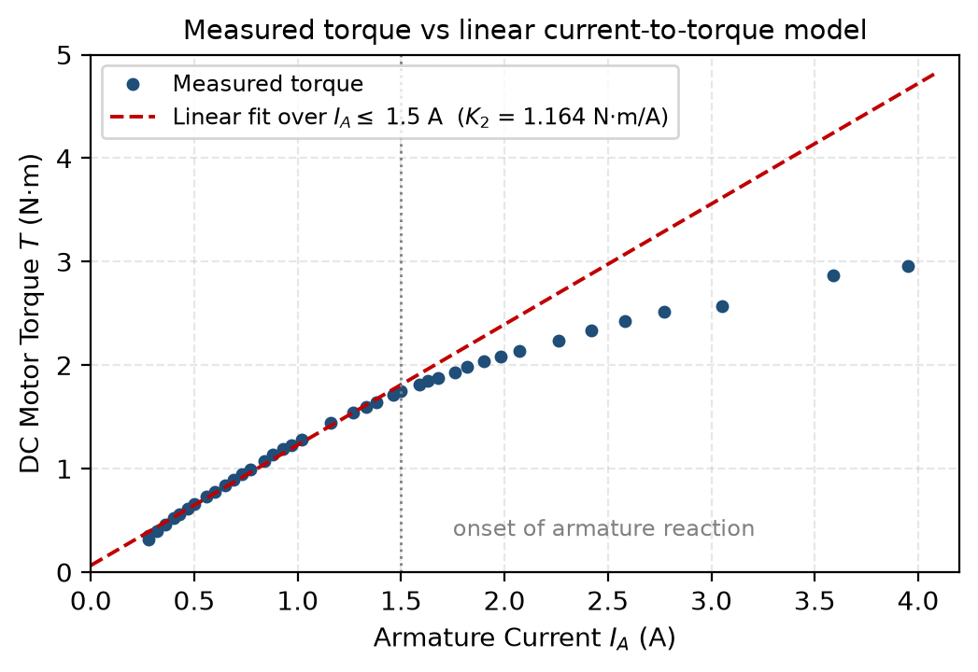
Figure 11: Measured torque compared with the linear current-to-torque model fitted below 1.5 A. The measured points fall progressively below the model as the armature current increases.
Table 8 quantifies the departure. Up to about 1.5 A the measured torque is within 3.5 % of the linear model, which is comparable with the resolution of the torque meter. Beyond that the shortfall grows rapidly and reaches 36 % at the highest current recorded.
Iₐ (A) | T measured (N·m) | T linear model (N·m) | Shortfall
1.50 | 1.75 | 1.81 | 3.4 %
1.63 | 1.85 | 1.96 | 5.7 %
1.76 | 1.93 | 2.11 | 8.7 %
1.90 | 2.04 | 2.28 | 10.4 %
2.07 | 2.14 | 2.47 | 13.5 %
2.42 | 2.34 | 2.88 | 18.8 %
2.77 | 2.52 | 3.29 | 23.4 %
3.59 | 2.87 | 4.24 | 32.4 %
Table 8: Departure of the measured torque from the linear current-to-torque model (alternate points shown).

This is attributed to armature reaction [1], [2]. The current through the armature windings sets up a magnetic field that is perpendicular to the direction of the main field. The vector addition of the cross-field to the main field results in the distortion of the flux, where there is an increase in flux at one pole tip and a decrease at the other. Since the iron near the increased flux region is already almost saturated, it is unable to take in the excess flux that is being taken away from the decreased region, and hence the flux per pole reduces. Torque is directly proportional to the product of flux and armature current; thus, at higher current, there will be lower flux, resulting in lower torque production, as is observed. This distortion results in shifting of the neutral plane away from where it was initially aligned when the brushes were aligned.
The practical significance is that the value quoted for K₂ is only meaningful if the current range over which it was determined is quoted with it. On that basis K₂ = 1.172 N·m/A is reported for Iₐ ≤ 1.5 A.

7.3 Predicted against measured speed droop
The comparison between the step 19 prediction and the corresponding measured points is the least satisfactory result of the exercise and merits careful examination.
Iₐ (A) | n predicted (r/min) | n measured (r/min) | at Iₐ (A) | Error
0.5 | 1410.6 | 1453.14 | 0.50 | -2.9 %
1.0 | 1327.4 | 1425.09 | 1.02 | -6.9 %
1.5 | 1244.2 | 1412.45 | 1.50 | -11.9 %
Table 9: Predicted speed from Table 6 compared with the nearest measured operating point in data table DT212.

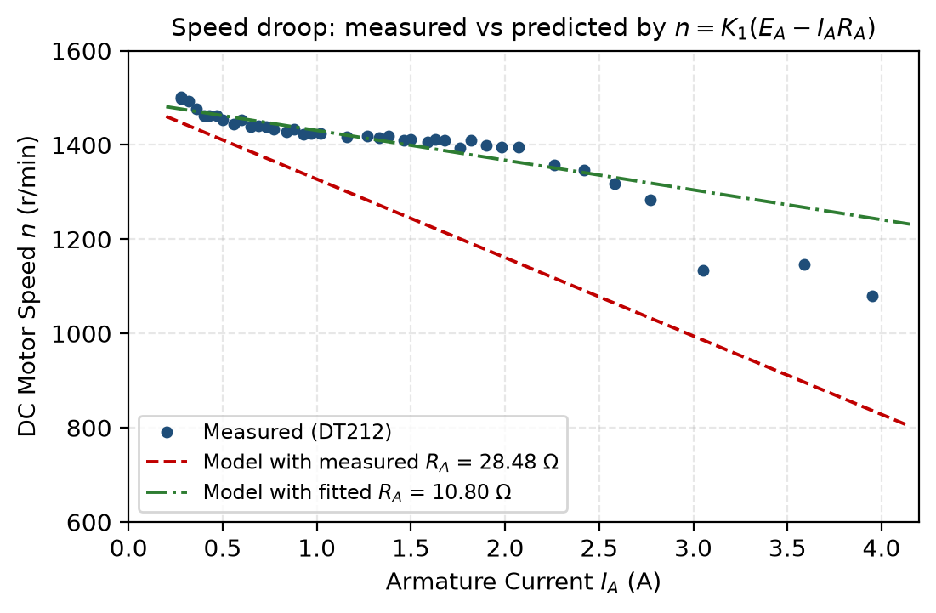
Figure 12: Measured speed droop compared with the model of equation (4), evaluated using the measured armature resistance and using a resistance fitted to the droop.
The model recreates the form of the characteristic, though greatly overstates its slope. For the linear section of the speed vs. armature current graph that is below 1.5 A, the gradient for the line of least squares is 63.1 r/min per ampere. Equation (4) with Rₐ equal to 28.48 Ω gives K₁Rₐ as 166 r/min per ampere.
Since the equation (4) has two measurable constants, there should be a problem with either of these. K₁ is known with an accuracy of less than 1% (see section 7.1), therefore armature resistance is questionable parameter. The use of equation (4) in form of linear function of Iₐ makes it possible to obtain an equivalent armature resistance from the behaviour of the motor itself, because gradient of this line is equal to −K₁Rₐ and intercept is K₁E.
 | Rₐ(effective) = − (dn / dIₐ) / K₁ | (17)
When applied to the 25 data points under 1.5 A, it gives Rₐ (effective) = 10.80 Ω, about 38% of the 28.48 Ω found in step 7. This regression also provides a good self-validation test of itself: its intercept at 1493.3 r/min corresponds to armature voltage of 255.65 V, very close to the 255.73 V measured in step 14, differing by just 0.08 V. The regression thereby validates the one data point available independently, lending credence to the resistance it calculates as well. Figure 12 illustrates the result directly: the data points fall close to the curve calculated from the lower resistance but far above the curve calculated from step 7's value.
The scatter about this fit (R² = 0.81) is considerably larger than for the no-load characteristic. That is expected: the speed readings fluctuate by several r/min at fixed load, the armature supply voltage drifted during the run, and the field current was not perfectly constant. These effects are examined in Section 7.6. None of them is large enough to account for a factor of 2.6.

7.4 Validity of the armature resistance measurement
Two defects in the step 7 measurement account for the discrepancy identified above.
The first, and more importantly, is the value of the current at which the test was conducted. It is very clear in the manual that the volt-ampere test is to be conducted at the rated value of the armature current because the brush contact drop is independent of the value of the current. The behavior of a carbon brush contact is that of a constant voltage drop of the order of one to two volts per brush and not a fixed resistance value, thus the apparent resistance ratio Eₐ/Iₐ will be higher when the current is low but decreases to its actual value when the current increases. The test was done at 0.507A, while the torque curve in Section 7.2 shows that the rated armature current of this motor is about 1.5A. Hence, the test was conducted at roughly one-third of the current value at which it should have been conducted, in the exact condition that the manual warns against.
The second drawback was that the rotor did not remain stationary. The speed meter showed −318.8 r/min and torque meter −0.341 N·m, which means that the shaft rotated at a slow speed in the backward direction and not that the shaft remained locked as required in the technique. When the field current was 0.001 A, then the flux was residual and hence, there was less production of the back-EMF but it was only a secondary factor after the brush drop; however, it implies that the assumption Eᴄᴇᴍᶠ = 0 in equation (6) was not entirely correct.
It is also important to know that the column RA = EA/IA of the data table DT212 is not armature resistance either. The values in this column are just the ratios of the terminal voltage to the armature current when the generator operates at back EMF and they are equal to numbers between 738 Ω and 61 Ω. This parameter is valid for the step 7 with the locked rotor and zero flux and has not been used elsewhere in this report.
If the test were to be carried out again, then the resistance test of the armature would be done at the rated armature current of the machine and ideally for different values of the current, such that the fixed brush drop can be distinguished from the actual ohmic resistance.

7.5 Energy conversion efficiency
The data acquisition software computed the ratio of mechanical output power to electrical input power for every operating point, plotted in Figure 13.
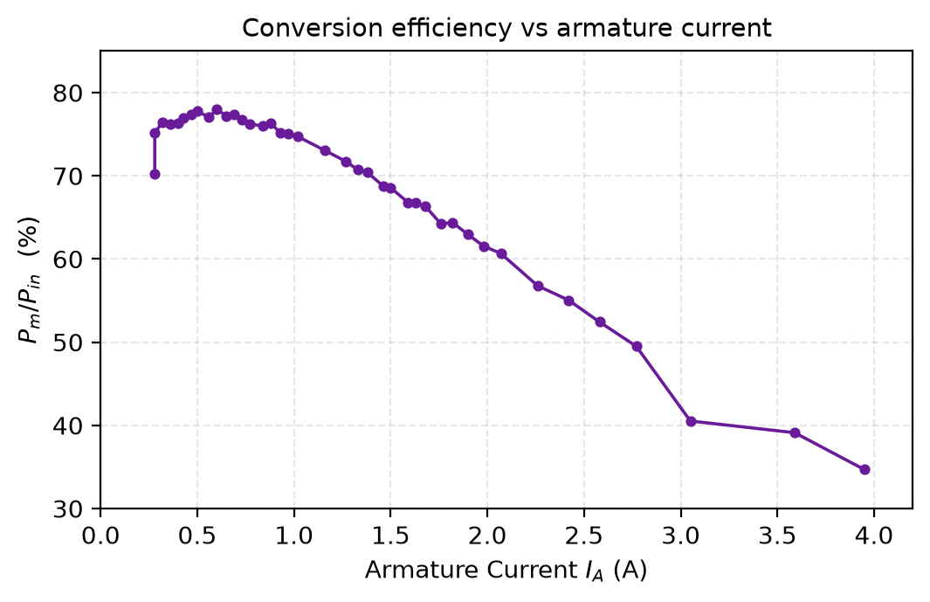
Figure 13: Ratio of mechanical output power to electrical input power as a function of armature current, computed by LVDAM-EMS from the DT212 data.
Efficiency jumps sharply from 70.2% at the light load up to 78.0% at an armature current of 0.60A before falling away consistently down to 34.7% at 3.95A. The graph has a typical form for any electrical machine. At light loads the fixed losses of friction, windage and losses in the field winding constitute a large proportion of the input energy, hence efficiency is low. As load increases the fixed losses are divided between a greater output energy and efficiency is therefore improved. Past the peak point, the armature copper losses which are proportional to the square of the armature current come to dominate and efficiency drops off. This happens when the variable losses become equal to the fixed losses.
The efficiency maximum offers further evidence for the conclusion drawn in Section 7.4 about the machine having been run significantly above its rated capacity at the upper end of the range. Running the machine at 3.95 A produced only one-third of the input power as mechanical power, with the rest lost in the form of heat – an unsustainable and unrepresentative situation.

7.6 Sources of error and experimental limitations
- Armature Resistance Test Current. Mentioned in Section 7.4, it is the largest source of uncertainty and directly propagates to every forecast derived from Eq. (4).
- Drift of the Armature Supply Voltage. As described in Step 15, the voltage must be trimmed back to its original value after each increment of torque. In reality, the measured voltage dropped steadily from 255.73 V to 243.25 V over the course of the experiment, a decline of 4.9 %. Thus, part of the recorded speed reduction was caused by lower supply voltage, not by load. The regression used in Section 7.3 accounts for it by including the intercept, hence the difference between the implied and originally set armature voltage (255.65 V and 256.47 V respectively).
- Thermal Drift. According to the manual, torque measurements should be performed within five minutes due to excess of the armature current over its nominal value. The copper resistivity increases by approximately 0.4 % per kelvin, thus increasing the actual armature resistance due to progressive winding heating during the run.
- Field current changes. The measured field current changed from 0.20 A to 0.19 A for the maximum loads. As K₁ and K₂ are dependent on flux, this makes the field a bit weaker and results in an extra speed increase in addition to the droop effect.
- Accuracy of instrument readings. Armature current and torque measurements were made with accuracy up to two decimal places. At the minimum value of torque of 0.32 N·m the quantisation error is roughly 3 % of the measurement, hence the scattering of the light load data points about the line of fit.
- Neutral position of brushes. Brushes were centred at the beginning of the experiment in unloaded mode. Armature reaction changes the magnetic neutral axis as the load changes, so the brushes are no longer well-centred in case of higher current.
- Limited number of measurements. Only one measurement for each operating point was made, hence there was no possibility to estimate the random errors. It would be better to make two or three sweeps and average the results.

8.0 Conclusion
The operating characteristics of a separately-excited DC motor were measured and compared against the simplified equivalent circuit model. The principal quantitative outcomes are summarised in Table 10.
Quantity | Symbol | Result | Basis
Armature resistance | Rₐ | 28.48 Ω | Volt-ampere method at 0.507 A
Effective armature resistance | Rₐ(eff) | 10.80 Ω | Fitted to the measured speed droop
Voltage-to-speed constant | K₁ | 5.841 r/min/V | DT211 end points, R² = 0.9998
Current-to-torque constant | K₂ | 1.172 N·m/A | DT212 linear portion, Iₐ ≤ 1.5 A
Speed regulation at 1.5 A | %SR | 6.31 % | DT212
Speed regulation at 3.95 A | %SR | 39.05 % | DT212
Peak conversion efficiency | η | 78.0 % | at Iₐ = 0.60 A
Table 10: Summary of measured and derived machine parameters.

The experiment proved the existence of two linear dependencies on the basis of which the model is built. With zero load, the speed was directly dependent on the armature voltage with R² = 0.9998, thus proving the fact that the device can operate as a linear converter of the voltage into the speed. With constant armature voltage, the torque was directly dependent on the armature current with R² = 0.9943 up to about 1.5 A, thus proving the fact that the device can also operate as a linear converter of the current into torque.
Above 1.5 A the torque dependency was slightly deviated from linearity, with the gap between the theoretical and actual results reaching 36% at 3.95 A. This was defined as the armature reaction, during which the effect of the magnetisation of the armature current along with the saturation of the pole tip resulted in the reduced net flux per pole.
Prediction of speed droop had the right qualitative result, yet a poor quantitative estimate that was off by a factor of 2.6. It was found to be due to the fact that the measurement of the armature resistance was done at the current of 0.507 A instead of at the rated armature current, which is estimated to be about 1.5 A on the basis of the torque characteristic. At such currents the brush contact voltage drop becomes non-linear and dominates the measured terminal voltage, thus providing an incorrect value for the resistance, which is exactly the effect that we are trying to avoid using the volt-ampere method described in the manual. Using the proper resistance value of 10.80 Ω fitted from the machine's own characteristic gives an excellent agreement between the predicted and measured characteristics.
The most important lesson learned from the lab was the final point. Even a measurement that seems perfectly fine on its own – one voltage and one current measured and divided properly – can actually be quite inaccurate if it is made in conditions that break an assumption of the method. It is by comparing the parameter to other measurements, like in this case, that the mistake is found.

9.0 References
[1] S. J. Chapman, Electric Machinery Fundamentals, 5th ed. New York, NY, USA: McGraw-Hill, 2012.
[2] School of Engineering, “Laboratory session: DC machines — DC motors,” ENS5230 Laboratory 2 manual, Edith Cowan University, Joondalup, WA, Australia, 2026.
[3] Lab-Volt Ltd., DC Motors and Generators, Electromechanical Training System. Quebec, Canada: Lab-Volt Ltd.
[4] A. E. Fitzgerald, C. Kingsley, and S. D. Umans, Electric Machinery, 6th ed. New York, NY, USA: McGraw-Hill, 2003.
[5] P. C. Sen, Principles of Electric Machines and Power Electronics, 3rd ed. Hoboken, NJ, USA: Wiley, 2013.

10.0 Acknowledgement of Generative Artificial Intelligence
[REVIEW AND EDIT THIS SECTION SO THAT IT ACCURATELY AND COMPLETELY DESCRIBES YOUR OWN USE OF AI TOOLS, THEN DELETE THIS INSTRUCTION.]
I acknowledge the use of [INSERT TOOL NAME AND VERSION NUMBER] in the preparation of this report. The tool was used for the following purposes:
- Transcribing the numerical readings from the LVDAM-EMS data table screen captures into a machine-readable form for calculation.
- Performing and checking the arithmetic and least-squares regressions reported in Sections 5 and 7.
- Producing Figure 10, Figure 11, Figure 12 and Figure 13 from the transcribed data.
- Providing feedback on the structure, clarity and grammar of the written discussion.
All laboratory measurements reported are my own, recorded during the Laboratory 2B session on 2 September 2026. I have verified every figure reproduced in this report against the original screen captures in Appendix A, and I take full responsibility for the interpretation, analysis and conclusions presented.

Appendix A — Timestamped Laboratory Recordings
The screen captures reproduced below are unmodified full-screen images taken on the laboratory computer during the Laboratory 2B session. The Windows taskbar clock and date are visible in the lower right corner of each image, as required by the assignment instructions. They are presented in the order in which they were recorded.
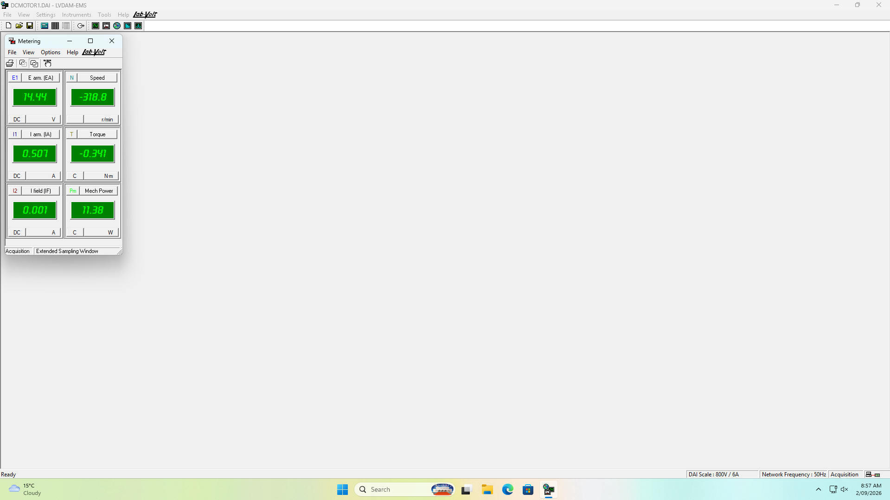
Figure 14: 08:58 — Metering window during the armature resistance test (step 7). The field current of 0.001 A confirms the stator was unexcited; E arm. 14.44 V and I arm. 0.507 A.
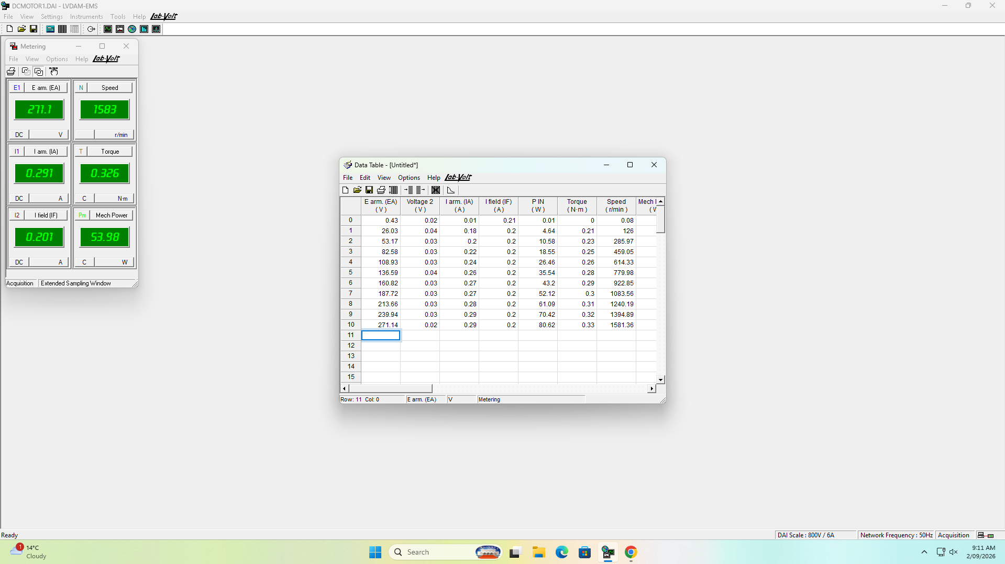
Figure 15: 09:11 — Data table DT211 complete, showing all eleven no-load operating points from 0.43 V to 271.14 V.

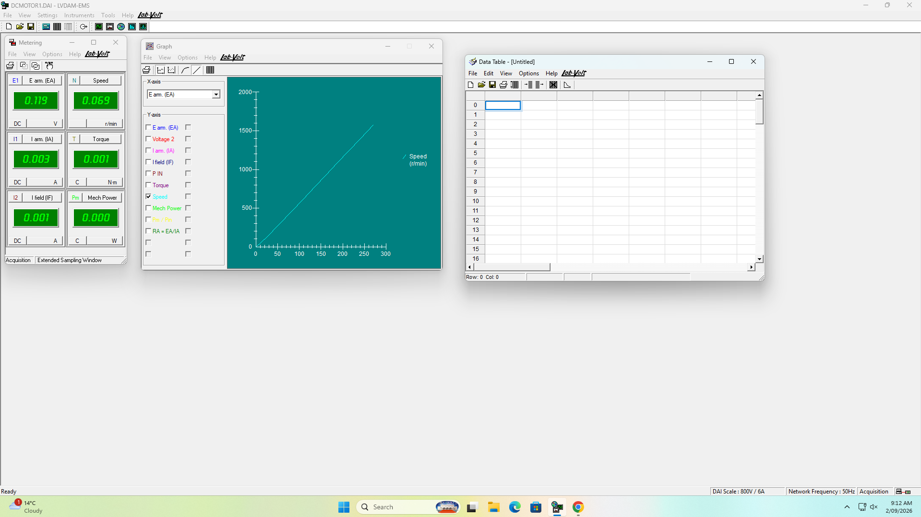
Figure 16: 09:12 — Graph G211, motor speed as a function of armature voltage.
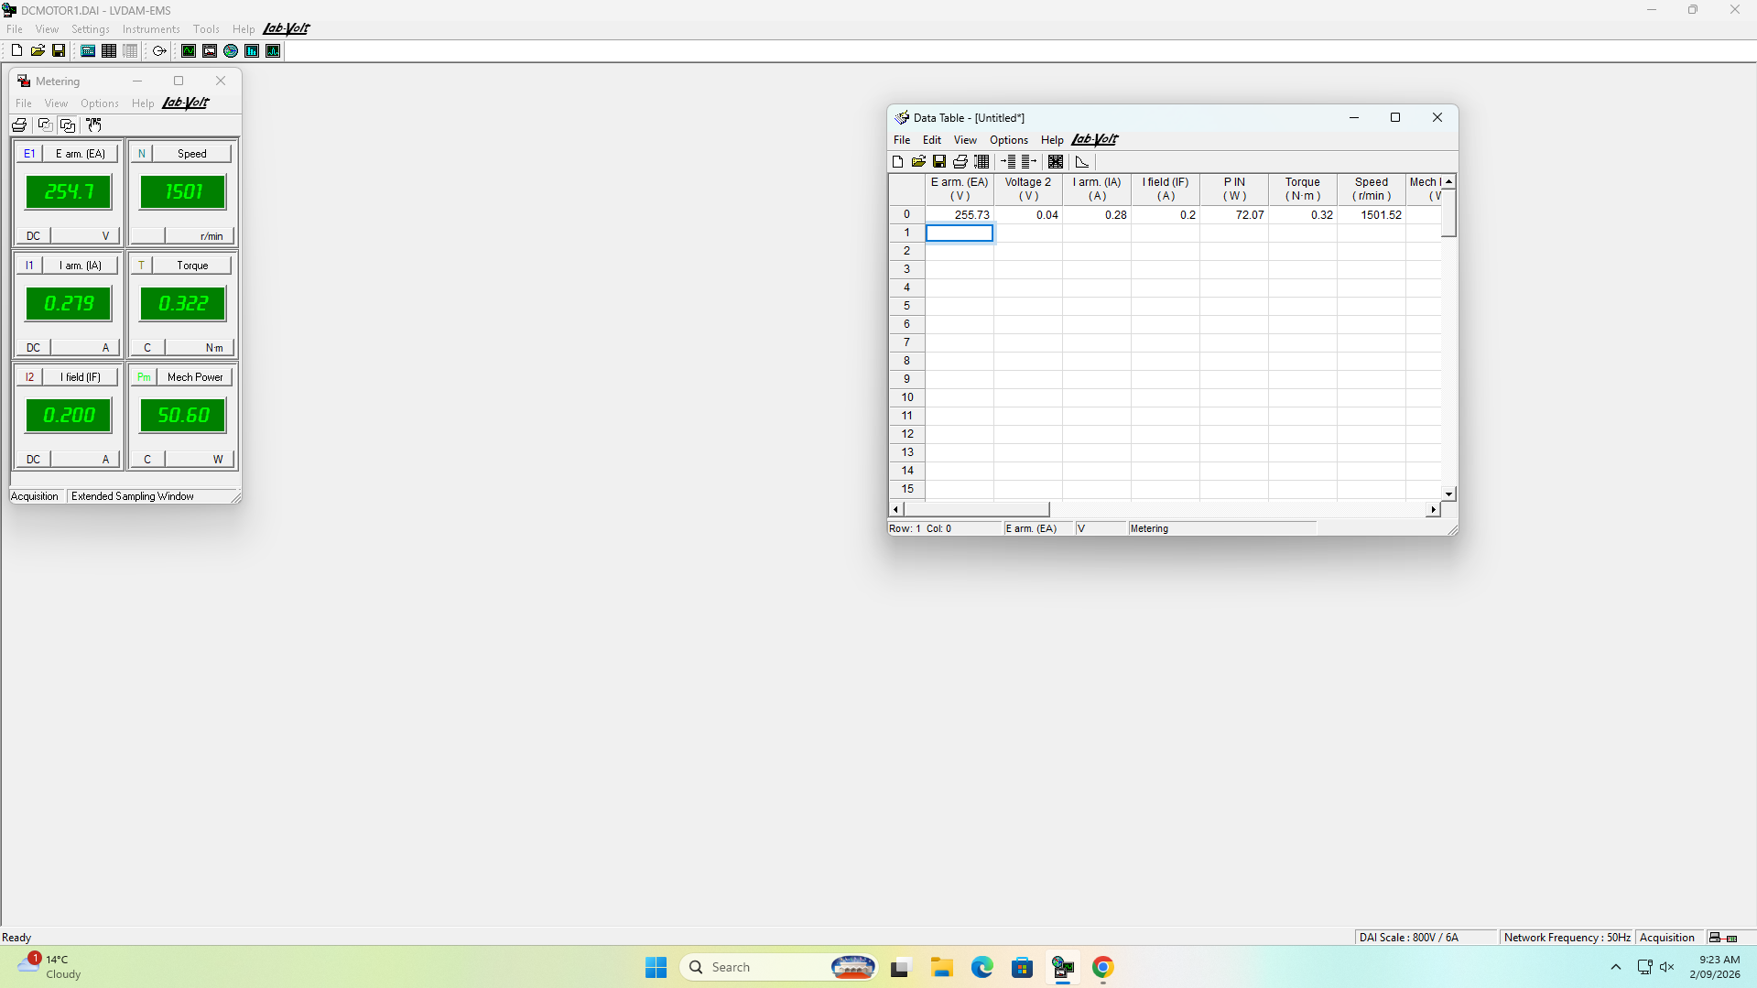
Figure 17: 09:23 — Step 14: armature voltage set to give a no-load speed of 1500 r/min. E arm. 255.73 V, speed 1501.52 r/min, recorded as the first row of DT212.

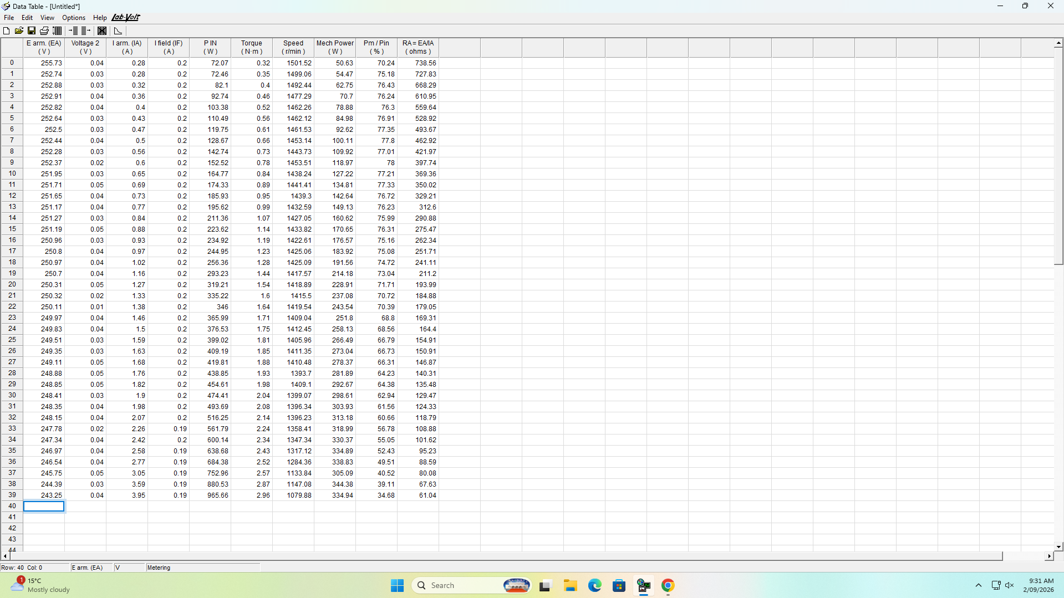
Figure 18: 09:31 — Data table DT212 complete, showing all forty loaded operating points from 0.28 A to 3.95 A. This is the dataset used throughout Sections 5 and 7.
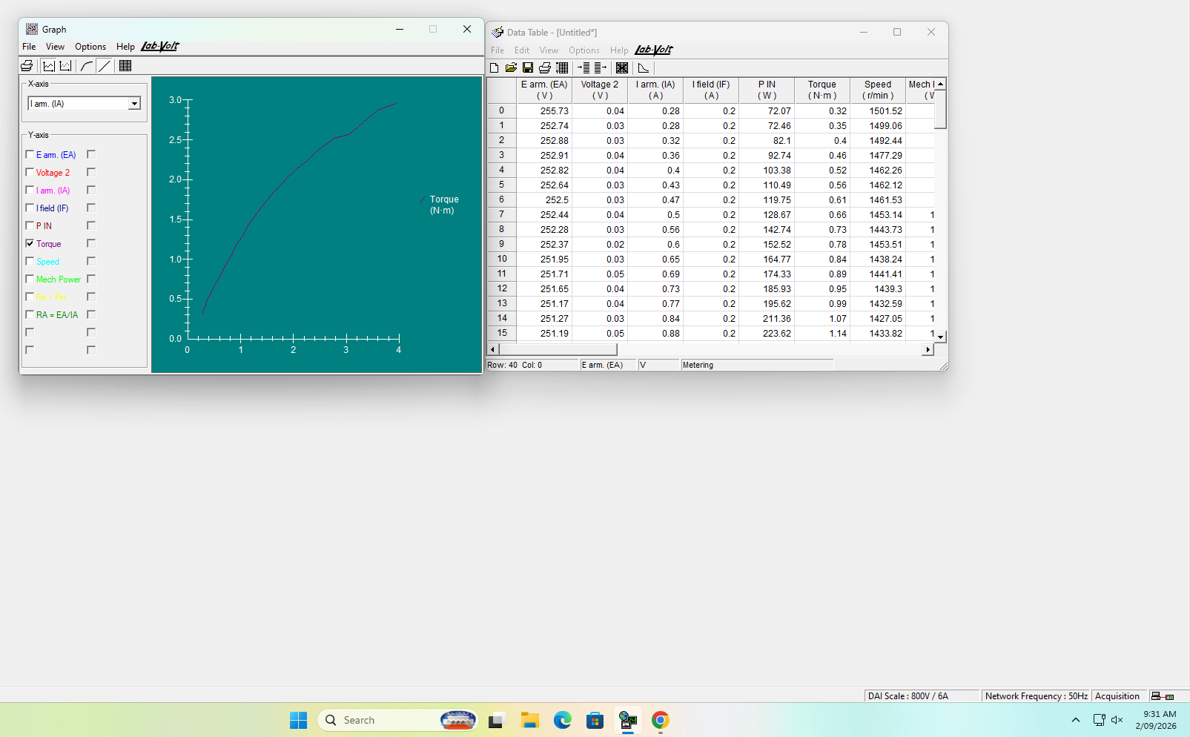
Figure 19: 09:31 — Graph G212, motor torque as a function of armature current, showing the departure from linearity above approximately 1.5 A.

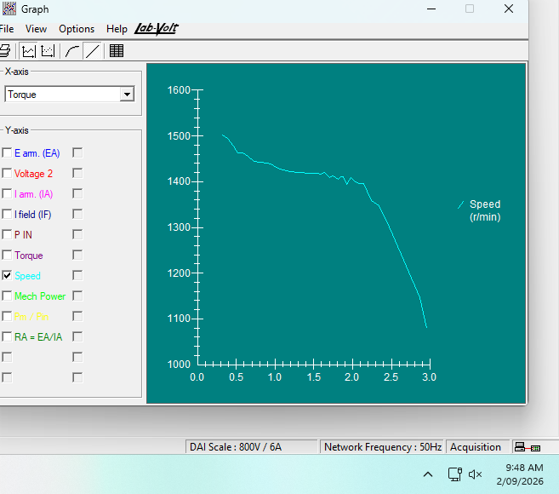
Figure 20: 09:48 — Graph G212-2, motor speed as a function of developed torque.
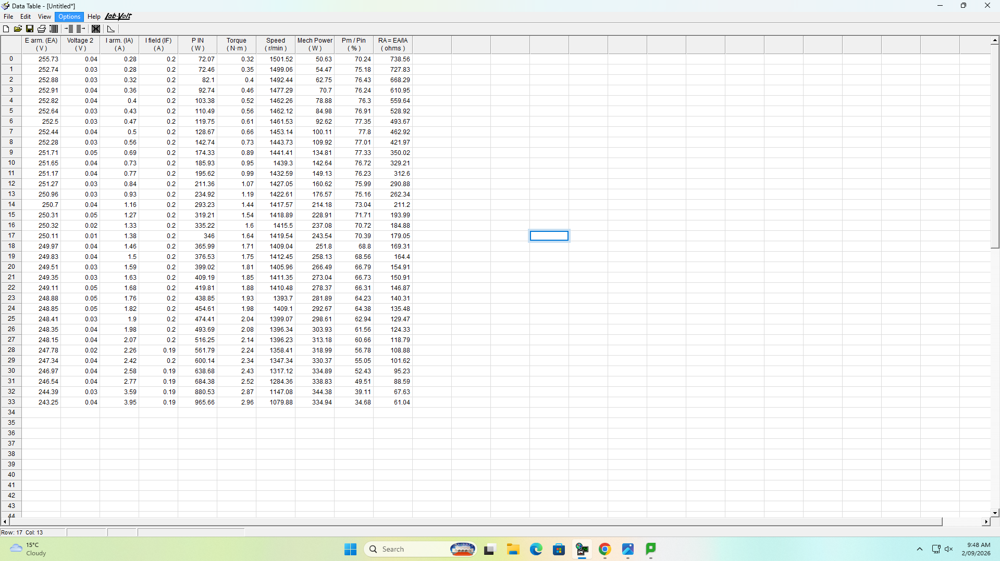
Figure 21: 09:48 — Data table displayed alongside graph G212-2.

